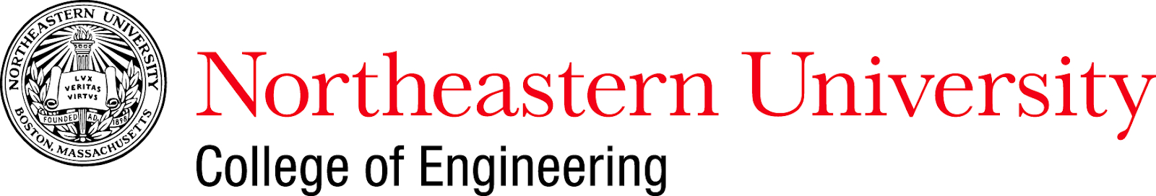

**API Wrapper Project Proposal**

Course Title: Introduction to Programming for DS

Course Number: DS5010

**Authors**

Yixuan Feng

Sean Klein

Faith Nassiwa

Muzhi Wu

04/03/2022

**SUMMARY**

The purpose of this project is to build an API Wrapper package in Python that encapsulates multiple API calls. The goals of this project include: -

* Develop a package that is designed specifically for Python to access [Public APIs](https://github.com/public-apis/public-apis) (Matheus 2022), taking advantage of Python's unique language features and working smoothly with Python's data types.
* The API wrapper will encapsulate multiple API calls and simplify the process of interacting with Web APIs by running functions for accessing the data.
* Document the API purely in Python terms, convert the JSON data into data frame, so that the programmer does not need to read the documentation, and translate into Python.

**Proposed Design**

The API Wrapper package will have two main classes. The first class is the PublicAPI class that will be used for capturing and storing the base URL and endpoints of the APIs. The second class is the APIWrapper class that will be used to get the public API data and format it in the required data format (Morast 2021) . It will implement most of the functions of the package, for example get_data(url, auth_key), format_data(response), create_data_frame(data).

We shall use standard python libraries and some external modules to implement the API Wrapper package functionalities. Below is a list of modules/libraries we plan to use:

* Requests – will be used for making requests to the public APIs and get data of the available end points.
* Json – will be used for formatting the data responses from the API calls.
* Pandas - will be used for shaping the data responses into a data frame.
* Pytest – will be used for automating creating and running tests.

Due to the different data formats available in the multiple public APIs, we anticipate it might require more time to cater to all the formats. For the scope of this project, we shall test with 1-2 APIs that can be used to demo the use of the package and continue to build on it to support more public APIs.

**References**

1. Matheus Felipe, Dave Machado, Pawel Borkar, James Brooks, Marek Dano, Mike Street, Todd Motto, Yann Bertrand, Wes Bos, olekstomek, Nirjas Jakilim, APILayer, Hugo Torzuoli, marijaninjo, Fernando Montoya, Karl L. Hughes, Hardik Pithva, Abdul Awali, Fawaz Ahmed, … Sergio Infante. (2022). yixuan-feng/public-apis: api (api). Zenodo. <https://doi.org/10.5281/zenodo.6409826>
2. Morast, Anthony. 2021. "Creating a python api wrapper (ally invest API)" Analytics Vidhya. February 10. Accessed April 1, 2022. https://medium.com/analytics-vidhya/creating-a-python-api-wrapper-ally-invest-api-568934a1411c